Queen’s College Student Conference
Queen’s College, Georgetown, Guyana
February 16 and 17, 2017
Theme: Empowering and Inspiring Youth for the Future

The Youth Development Fund of the Queen's College of Guyana Alumni Association (NY) Inc. (QCAANY) is delighted to announce its third student conference, scheduled for February 16 and 17, 2017 at Queen’s College, Georgetown, Guyana. With the theme of Empowering and Inspiring Youth for the Future, this year’s conference will reach 200 students from Queen’s College and six other secondary schools. The conference will be comprised of two sessions of concurrent workshops, team projects, a career fair, and sports. Alumni volunteers and a few friends from Guyana and the diaspora will lead the various conference elements.
The seeds that will be planted within attendees during this action-packed conference will contribute to their leadership development, career development, and post-secondary education success. Attendees will also be positioned to contribute to the further development of Guyana.

One of our 2015 conference presenters received this email in January 2017 from a student:

“You might not remember me but I'm PT one of your pupils who you taught at the workshop in Queen’s College. I'm writing exams this year for CXC and so far everything you have taught helped me allot and I've done extremely well in my end of terms exams for Maths and I.T..so, I thank you a great lot and look forward to seeing you in the future.”

We need your support so that we can continue to positively impact the lives of students like PT. Please use the attached form to pledge a generous sponsorship. Remember that QCAANY is a 501(c)3, US tax-exempt organization. Therefore, US donors will enjoy a tax deduction on their sponsorships. Sponsorship commitments are due on or before January 31, 2017.

We look forward to your support!

Karen Wharton
President, QCAANY
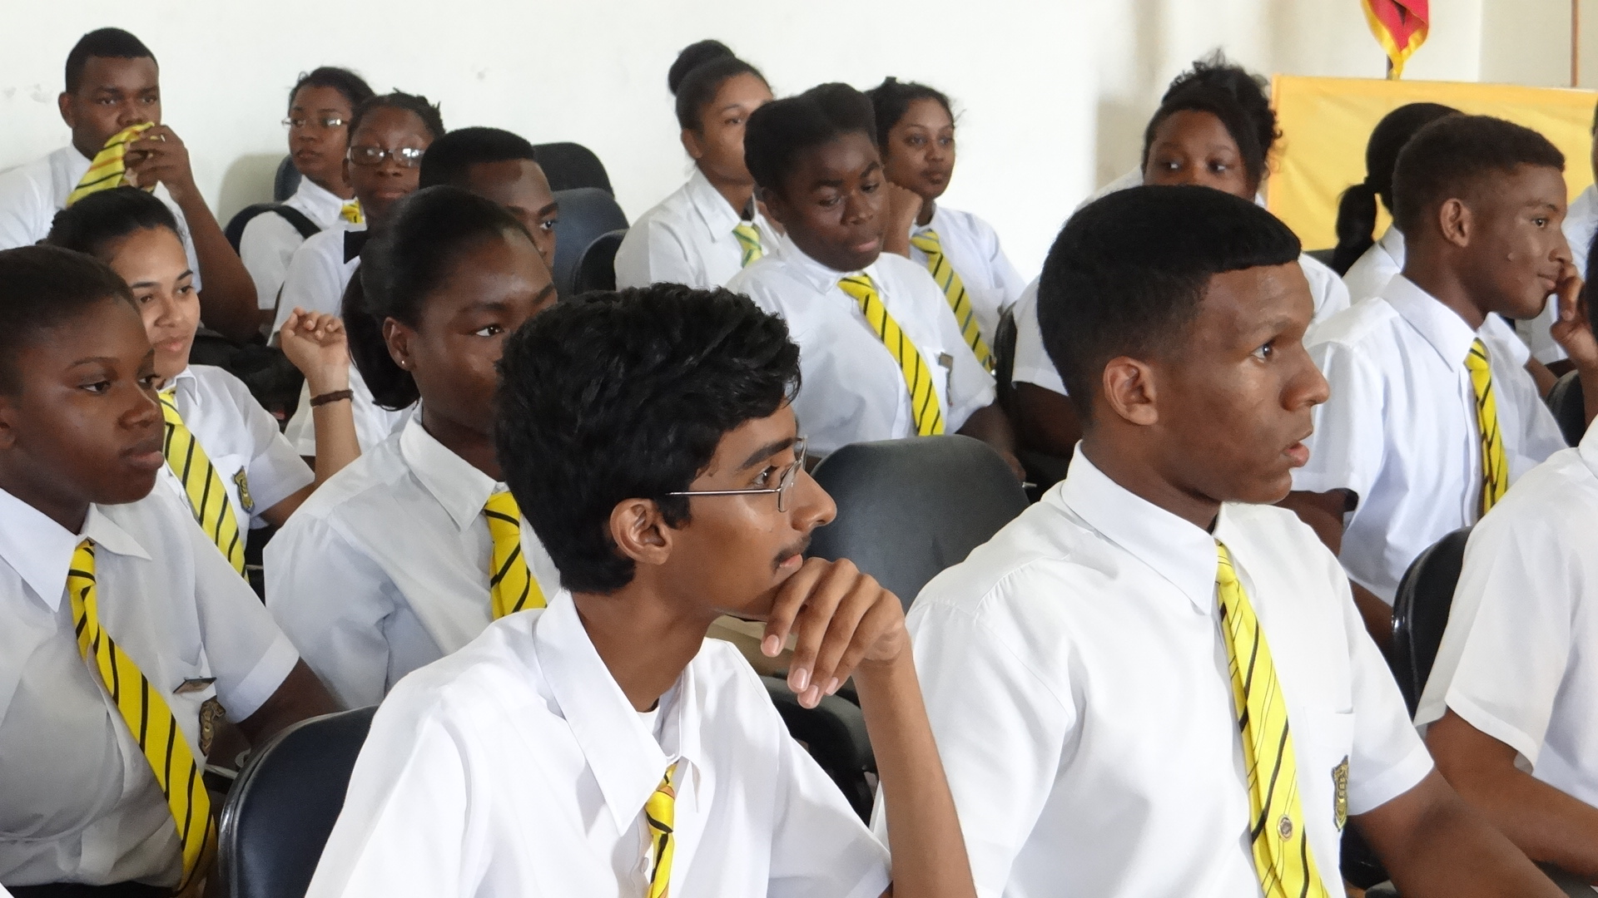

Queen’s College Student Conference
February 16 and 17, 2017
SPONSORSHIP FORM

Name: Company Name:

Address:

Phone: Email:

Sponsorship Opportunities

Gold $2,500US/$150,000GY
- Premium Full Page Ad in Conference Book (back or inside covers)
- Opportunity to Greet the Audience at the Opening or Luncheon Plenary Session
- Name and Logo on Signage at Event
- Logo and Business Website Link on QCAANY Website for One Year
- Logo and Business Website Link on Conference Website
- FaceBook Acknowledgment

Silver $1,000US/$100,000GY
- Full Page Ad in Conference Book
- Name and Logo on Signage at Event
- Logo and Business Website Link on Conference Website
- FaceBook Acknowledgment

Bronze $500US/$50,000GY
- Half Page Ad in Conference Book
- Logo and Business Website Link on Conference Website
- FaceBook Acknowledgment

Preferred Sponsorship Level/Contribution:
(All sponsorships, regardless of size, are welcomed)

Date we should expect to receive your funds:

We will gladly accept your sponsorship funds by check (payable to QCAANY)
or online at npo.justgive.org/qcaany
Please return form/check to QCAANY, c/o Karen Wharton, President at studentsconf@qcguyanaalumny.org /3709 Avenue M, Brooklyn, NY 11234
Karen can be reached at 917.821.1828 with questions

Deadline for Sponsorship Commitments: January 31, 2017

